# Subscription System

This application uses MailerSend for sending emails

Use Case [Admin Registration] → [Admin Login] → [Fiscal Code Setup] → [Send Invitation] → [User Registration] → [User Login] → [User Dashboard]

1. Admin Register screen with the mocked token

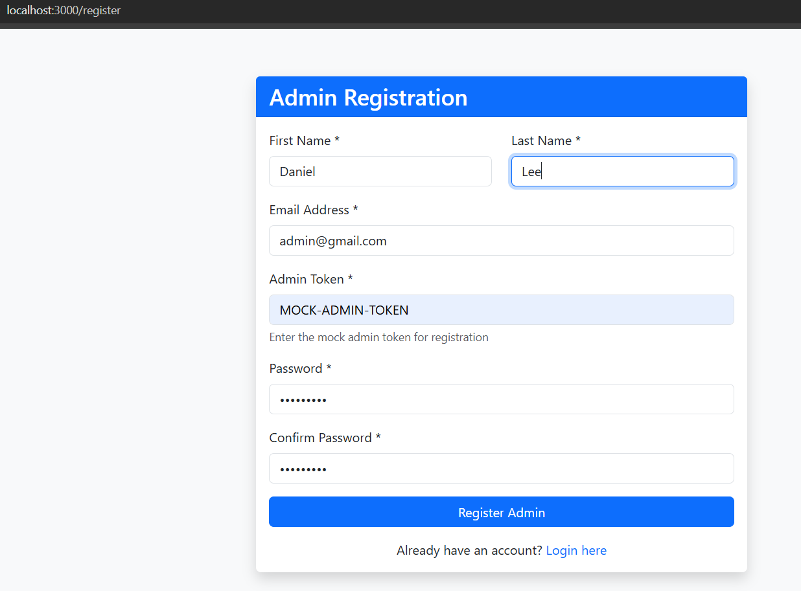

2.Admin is redirected to login panel after login successfully done

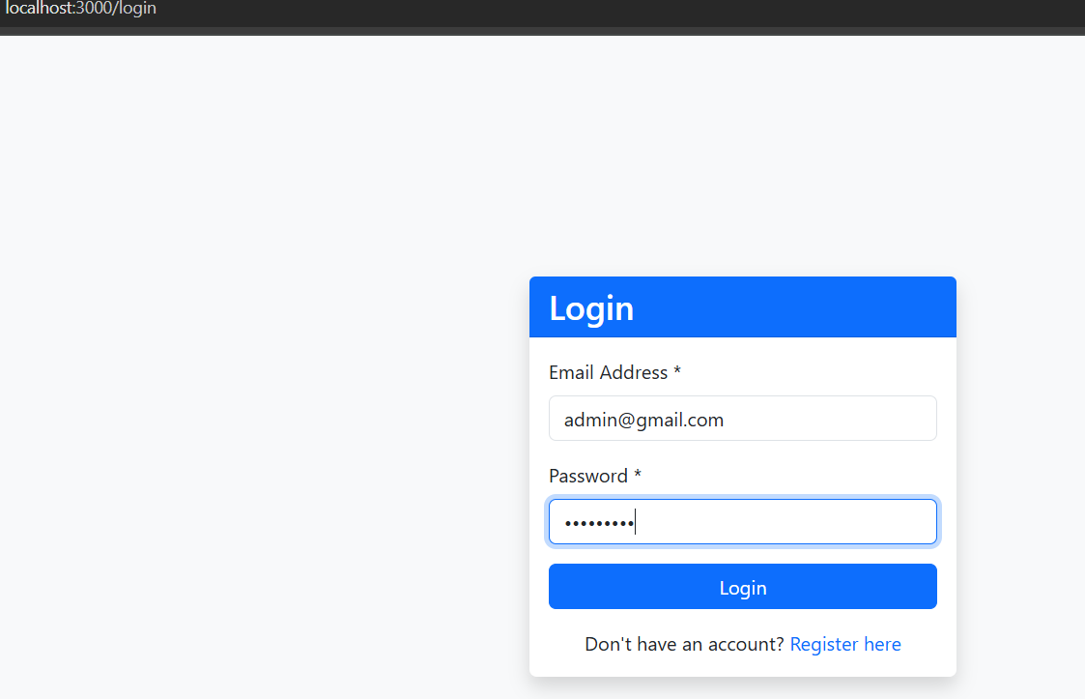

3.Admin has the option to proceed further with the fiscal Code

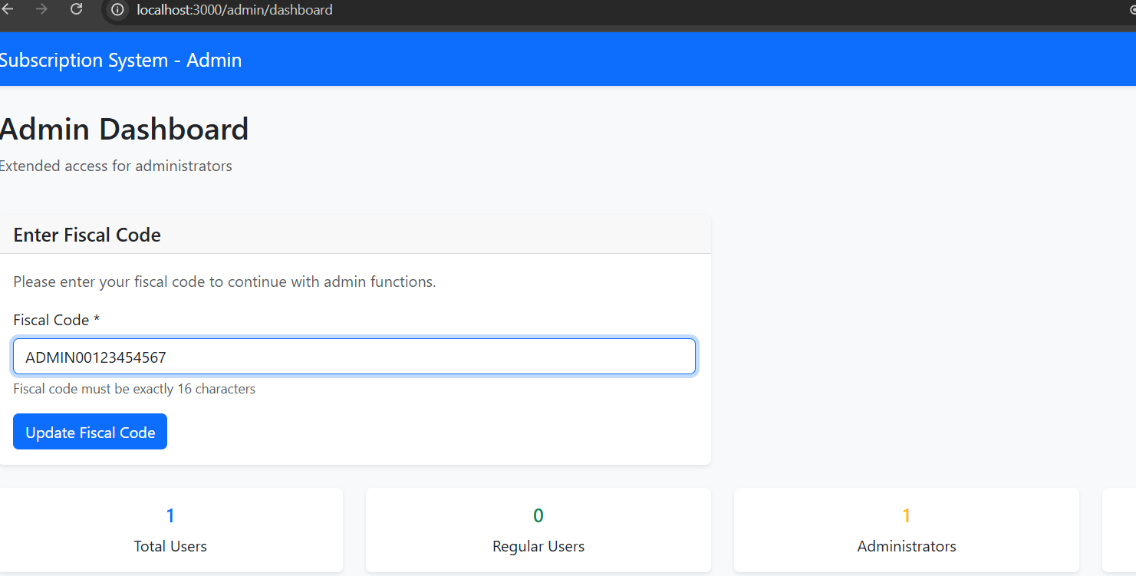

4.After updating the fiscal code admin is able to send email

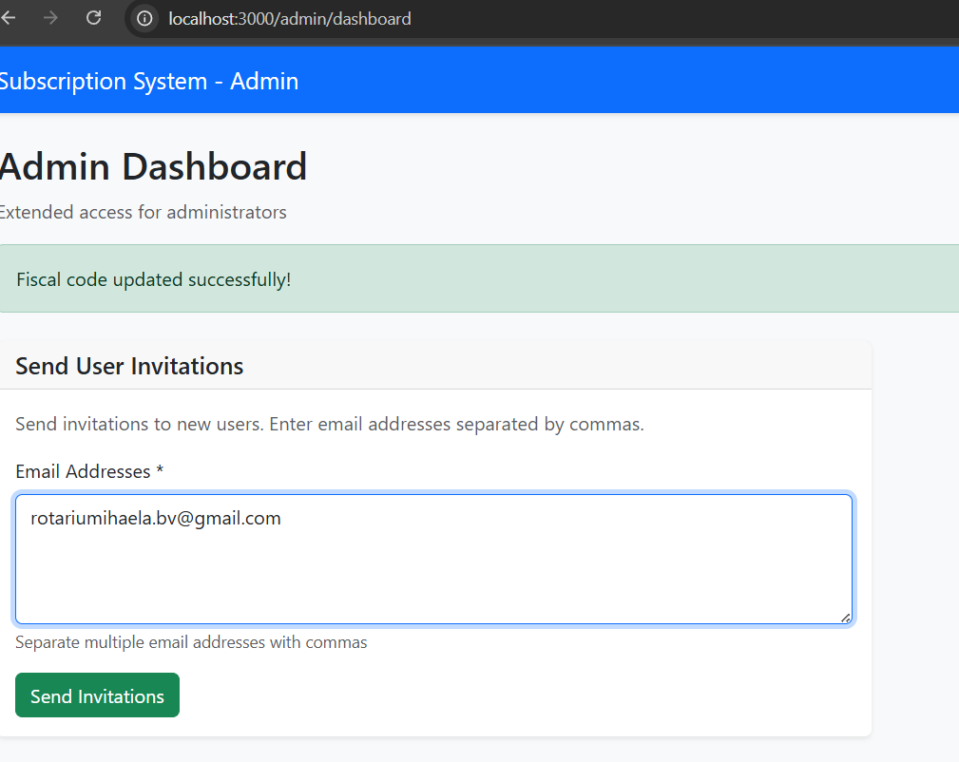

5. The user receives an email with a confirmation link



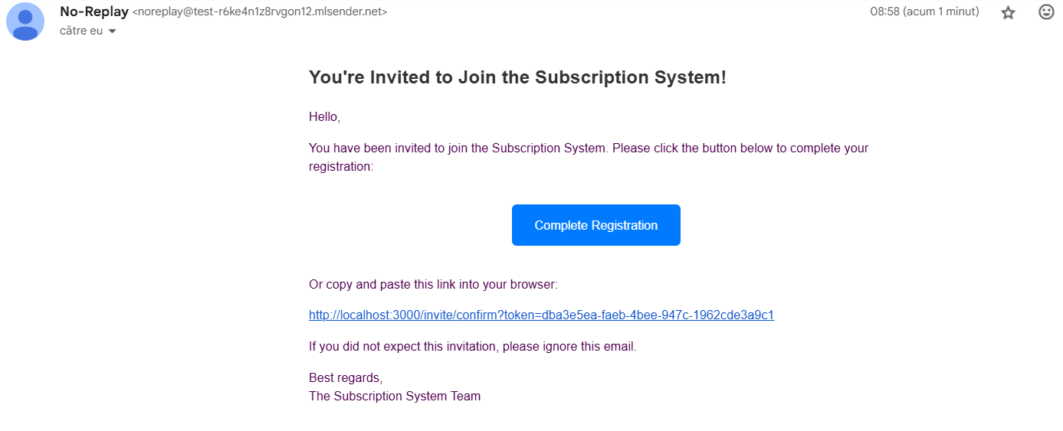

6. User proceeds the registration and is registered successfully

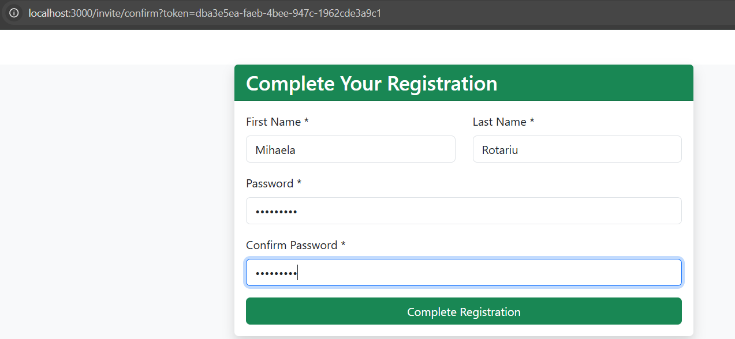

7.User loges in

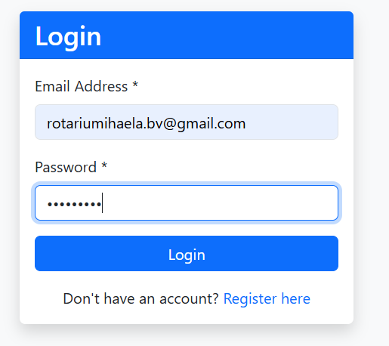

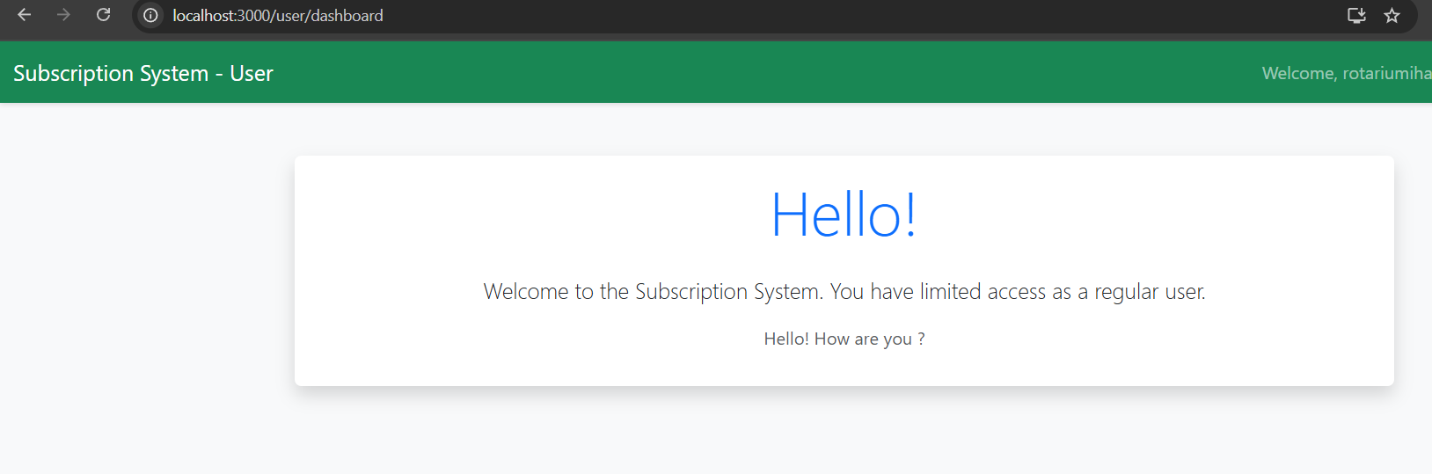8. User can see his panel